RecycleView với layout nhiều loai

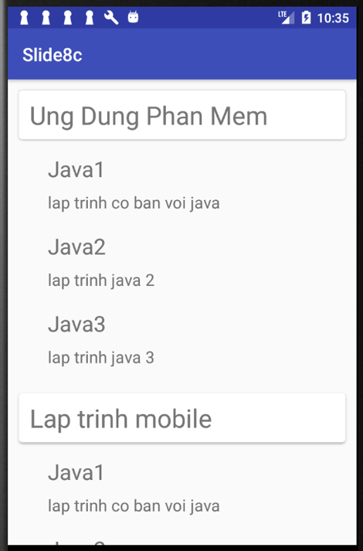

1. Tạo project

compile **'com.android.support:cardview-v7:25.3.1'**compile **'com.android.support:recyclerview-v7:25.3.1'**

1. Layout chính dùng RecycleView

<**android.support.v7.widget.RecyclerView  
 android:id="@+id/recycleview"  
 android:layout_width="match_parent"  
 android:layout_height="match_parent"**>  
</**android.support.v7.widget.RecyclerView**>

1. Tạo layout mới tên “item_nganh.xml”

*<?***xml version="1.0" encoding="utf-8"***?>*<**android.support.v7.widget.CardView  
 xmlns:android="http://schemas.android.com/apk/res/android"  
 xmlns:card_view="http://schemas.android.com/apk/res-auto"  
 android:layout_width="match_parent"  
 android:layout_height="wrap_content"  
 android:layout_margin="12dp"  
 card_view:cardCornerRadius="4dp"**>  
 <**TextView  
 android:id="@+id/titleTextView"  
 android:layout_width="match_parent"  
 android:layout_height="wrap_content"  
 android:layout_marginLeft="12dp"  
 android:layout_marginRight="12dp"  
 android:layout_marginTop="8dp"  
 android:layout_marginBottom="8dp"  
 android:textSize="28sp"** />  
</**android.support.v7.widget.CardView**>

1. Tạo layout mới tên “item_mon.xml”

*<?***xml version="1.0" encoding="utf-8"***?>*<**LinearLayout  
 xmlns:android="http://schemas.android.com/apk/res/android"  
 android:orientation="vertical"  
 android:layout_width="match_parent"  
 android:layout_height="wrap_content"  
 android:paddingLeft="32dp"  
 android:paddingBottom="12dp"**>  
 <**TextView  
 android:id="@+id/titleTextView"  
 android:layout_width="match_parent"  
 android:layout_height="wrap_content"  
 android:layout_marginLeft="12dp"  
 android:layout_marginRight="12dp"  
 android:layout_marginTop="4dp"  
 android:layout_marginBottom="4dp"  
 android:textSize="24sp"**/>  
 <**TextView  
 android:id="@+id/descriptionTextView"  
 android:layout_width="match_parent"  
 android:layout_height="wrap_content"  
 android:layout_marginLeft="12dp"  
 android:layout_marginRight="12dp"  
 android:layout_marginTop="4dp"  
 android:layout_marginBottom="4dp"  
 android:textSize="18sp"** />  
</**LinearLayout**>

1. Tạo class mới tên Nganh.java

**public class** Nganh {  
 **public static final int *LOAI_NGANH*** = 0;  
 **public static final int *LOAIMON*** = 1;  
 **public** String **ten**;  
 **public** String **mota**;  
 **public int loai**;  
 **public** Nganh(String ten, String mota, **int** loai) {  
 **this**.**ten** = ten;  
 **this**.**mota** = mota;  
 **this**.**loai** = loai;  
 }  
}

1. Tạo class mới tên “MyAdapter.java”

**public class** MyAdapter **extends** RecyclerView.Adapter<RecyclerView.ViewHolder> {  
  
 **private** List<Nganh> **ds**;  
 **public** MyAdapter(List<Nganh> list) {  
 **this**.**ds** = list;  
 Log.*d*(**"dulieu"**,**this**.**ds**.size()+**""**);  
  
 }  
  
 **public static class** NghanhViewHolder **extends** RecyclerView.ViewHolder {  
 **private** TextView **ten**;  
 **public** NghanhViewHolder(View itemView) {  
 **super**(itemView);  
 **ten** = (TextView) itemView.findViewById(R.id.***titleTextView***);  
 }  
 }  
 **public static class** MonViewHolder **extends** RecyclerView.ViewHolder {  
 **private** TextView **ten**;  
 **private** TextView **mota**;  
 **public** MonViewHolder(View itemView) {  
 **super**(itemView);  
 **ten** = (TextView) itemView.findViewById(R.id.***titleTextView***);  
 **mota** = (TextView) itemView.findViewById(R.id.***descriptionTextView***);  
 }  
 }  
  
 @Override  
 **public** RecyclerView.ViewHolder onCreateViewHolder(ViewGroup parent, **int** viewType) {  
 View view;  
 Log.*d*(**"dulieu"**,**"onCreateViewHolder"**+viewType);  
 **switch** (viewType) {  
 **case** Nganh.***LOAI_NGANH***:  
 view = LayoutInflater.*from*(parent.getContext()).inflate(R.layout.***item_nganh***, parent, **false**);  
 **return new** NghanhViewHolder(view);  
 **case** Nganh.***LOAIMON***:  
 view = LayoutInflater.*from*(parent.getContext()).inflate(R.layout.***item_mon***, parent, **false**);  
 **return new** MonViewHolder(view);  
 }  
 **return null**;  
 }  
  
 @Override  
 **public void** onBindViewHolder(RecyclerView.ViewHolder holder, **int** position) {  
 Log.*d*(**"dulieu"**,**"onBind"**);  
 Nganh object = **ds**.get(position);  
 **if** (object != **null**) {  
 **switch** (object.**loai**) {  
 **case** Nganh.***LOAI_NGANH***:  
 ((NghanhViewHolder) holder).**ten**.setText(object.**ten**);  
 **break**;  
 **case** Nganh.***LOAIMON***:  
 ((MonViewHolder) holder).**ten**.setText(object.**ten**);  
 ((MonViewHolder) holder).**mota**.setText(object.**mota**);  
 **break**;  
 }  
 }  
 }  
  
 @Override  
 **public int** getItemViewType(**int** position) {  
 **if** (**ds** != **null**) {  
 Nganh object = **ds**.get(position);  
 **if** (object != **null**) {  
 **return** object.**loai**;  
 }  
 }  
 **return** 0;  
 }  
  
 @Override  
 **public int** getItemCount() {  
 **return ds**.size();  
 }  
  
  
}

1. Java chinh

**public class** MainActivity **extends** AppCompatActivity {  
  
 List<Nganh> **list** = **new** ArrayList<Nganh>();  
 @Override  
 **protected void** onCreate(Bundle savedInstanceState) {  
 **super**.onCreate(savedInstanceState);  
 setContentView(R.layout.***activity_main***);  
 taodulieu();  
  
 MyAdapter adapter = **new** MyAdapter(**list**);  
 LinearLayoutManager linearLayoutManager = **new** LinearLayoutManager(**this**, OrientationHelper.***VERTICAL***, **false**);  
 RecyclerView mRecyclerView = (RecyclerView) findViewById(R.id.***recycleview***);  
 mRecyclerView.setLayoutManager(linearLayoutManager);  
 mRecyclerView.setItemAnimator(**new** DefaultItemAnimator());  
 mRecyclerView.setAdapter(adapter);  
  
 }  
  
 **public void** taodulieu()  
 {  
  
 **list**.add(**new** Nganh(**"Ung Dung Phan Mem"**, **null**, Nganh.***LOAI_NGANH***));  
 **list**.add(**new** Nganh(**"Java1"**, **"lap trinh co ban voi java"**, Nganh.***LOAIMON***));  
 **list**.add(**new** Nganh(**"Java2"**, **"lap trinh java 2"**, Nganh.***LOAIMON***));  
 **list**.add(**new** Nganh(**"Java3"**, **"lap trinh java 3"**, Nganh.***LOAIMON***));  
 **list**.add(**new** Nganh(**"Lap trinh mobile"**, **null**, Nganh.***LOAI_NGANH***));  
 **list**.add(**new** Nganh(**"Java1"**, **"lap trinh co ban voi java"**, Nganh.***LOAIMON***));  
 **list**.add(**new** Nganh(**"Java2"**, **"lap trinh java 2"**, Nganh.***LOAIMON***));  
 **list**.add(**new** Nganh(**"Android co ban"**, **"lap trinh android co ban"**, Nganh.***LOAIMON***));  
 }  
  
}